**Pulmonary lobar segmentation from computed tomography scans based on statistical shape model**

1 Introduction

Human lungs are divided into five distinct anatomical regions, which are called the pulmonary lobes. These lobes separate airways and vessel trees into different branches, and are largely anatomical independent. The fissures between adjacent lobes contain pleural fluid and provide separation between the lobes while permitting some relative movement. In general, the functions of these lobes are relatively independent with each other since there are no major airways and vessels crossing the lobar fissures (Lassen et al 2010). Therefore, the extraction of these lobes is of great importance in applications of lung disease assessment and treatment planning. For clinical applications, the distribution and location of pulmonary disease are beneficial for doctors to recognize pathogenesis, guide therapy and have further value in surgical planning.

Currently, the most traditional method for CT scans lobe segmentation is tracking the lobar boundaries manually by an experienced pulmonary radiologist. The process of determining the lobar boundaries is an extremely laborious and time-consuming task. However, to find an effective and time-saving automatic lobe segmentation method is really challenging because of anatomical variation and incomplete fissures. On one hand, lobes vary between subjects. The anatomical variation of lobe is usually associated with age, sex and body type. Pathologies of diseased lungs usually deform the lobar shape abnormally and result in some fuzzy appearance of fissures on CT images, in particular in the presence of abnormalities near the fissures, which makes fissure segmentation challenging. On the other hand, even in patients with healthy lung parenchyma the fissures are usually incomplete (Gülsün et al 2006).

In a broad sense, the existing computational lobe segmentation methods usually consist of two steps: the lung segmentation and the fissure detection. Currently, quite a number of lung segmentation methods are well established to get a reliable result. In contrast, most challenges for automated lobar segmentation lie in the fissure detection even though a number of researches have been involved in. One kind of method depends on either local or global knowledge of the anatomy of lung structure such as airway and vessel trees. Kuhnigk et al (2003 2005) was early group to present a framework of making use of lobar airways and vasculature into account for automatic fissure detection. A watershed transformation method was used to take an analysis of these anatomical structures and this method was widely used and improved by other researches later, but the results with the simple algorithm was still inaccurate even for some clearly visible fissures. Ukil and Reinhardt (2009) developed Khnigk’s fissure detection method which combined a distance transform to segmented vessels and original chest CT scan as a cost image for a watershed transform guided by airway and vascular markers. The improved watershed transform algorithm could provide a close initial approximation to the lobar fissures and an initial search area for the lobar fissures was determined. Subsequently, a further refinement method was used to construct a region of interest (ROI) encompassing the fissures and a 3D optimal surface detection algorithm combined with a ridgeness measure based on the structure tensor analysis was then applied to enhance the ROI and finally find the optimal surface within the ROI. In the last step, incomplete fissures were smoothly extrapolated using a fast-marching method based segmentation of a projection of the optimal surface. However, some manual operations were still needed for about 20%-25% subjects. Lassen et al (2011) also described the fissure detection method by building a cost image for the watershed transformed segmentation which is an extension of the framework of Kuhnigk. The interactive segmentation method was tested on 25 CT scans comparing to a manual segmentation by a human observer and showed an average distance of 1.57+- 0.3mm. In addition, Zhou et al (2004) and Saita et al (2006) took advantage of the linear appearance of fissures to class the vessels and bronchi into five lobe regions using an edge detection method and the Hough transform based curved surface detection method, respectively.

The other kind of method commonly makes use of gray-level information and shape information to detect the fissures. Generally, lobar fissures can be regarded as bright planes crossing the pulmonary volume because of the higher density value of fissures comparing to the surrounding tissues. Based on this information, quite a number of published methods use local filtering algorithm to detect the voxels which lie on these planes, so that these detected voxel points can construct a continuous fissure surface. In 2D space, the fissure appears as a clear curve, therefore some early papers usually detected fissure points based on gray-level information in 2D space (Wang et al 2003, 2006, Kuhnigk et al 2003). For example, Wang et al (2003 2006) presented an approach for segmenting the major fissures on CT scans based on shape information. The fissure was initially denoted as a curve based on the prior knowledge of the shape of the fissure to identify the surrounding region of fissure, called “fissure region” for subsequent automatic segmentation. Next an image transformation called “ridge map” was proposed for enhancing the appearance of initial fissures. The shape-based curve-growing growing method modeled by a Bayesian network could then be applied to this “map” to segment the fissure. The method was applied to segment the fissures of chest CT of 10 patients with pulmonary nodules. The result showed that only 2.4% of the fissures required manual correction and the average distance between the automatic and manual segmented fissures was 1.01 mm.

In 3D space, the most common used method to detect these pulmonary fissure plane structures is taking an eigenvalue analysis of Hessian matrix (Frangi et al 1998, Wiemker et al 2005(a), Kitasaka et al 2006, Ochs et al 2007, van Rikxoot et al 2008, Ukil and Reinhardt 2009, Lassen et al 2011 2013, Ross et al 2010, Doel et al 2012). Frangi et al (1998) was the first to present eigenvalue analysis of Hessian matrix to detect plane structure such as fissure and tube structure such as vessel on CT images. The three eigenvalues of Hessian matrix gives a fissure probability for each voxel and the relation between the eigenvalues of the Hessian matrix describes the local image structure (Wiemker et al 2005(b)). Wiemker et al (2005(b)) was also an early paper to use Hessian matrix for fissure detection and two 3D filter approaches were proposed in this paper. The first filter was based on first derivatives of the image gray values and utilized the eigenvalues of the local structure tensor. The second filter was based on second derivatives and utilized the eigenvalues of the local Hessian matrix. Ochs et al (2007), van Rikxoot et al (2008) both used a pattern recognition approach to detect pulmonary fissures combined with eigenvalue analysis of Hessian matrix as feature and classification was also performed on these fissures. Lassen et al (2011 2013) utilized the eigenvalue analysis of Hessian matrix based on the initial approximation fissures from anatomical structure of airway and vessel trees. This algorithm combined with two types of methods could reduce many false points since the first anatomic-based method could find a region of interest which made the analysis of Hessian matrix only work in the surrounding area of the initial guessing fissure locations. Subsequently, morphological operations such as direction-based connected component analysis were also used to further reduce some non-fissure points. The average distance between automatic fissures and the reference for 55 CT scans were 0.98 mm, 3.97 mm and 3.09 mm for the left oblique fissure, right oblique fissure and right horizontal fissure respectively. Ross et al (2010) proposed a particle system that sampled the image domain combined with Hessian matrix to get a set of candidate fissure locations. A maximum a posteriori (MAP) estimation was followed to eliminate false candidate points and a post-processing operation was applied to remove remaining noise points. A thin plate spline (TPS) interpolating surface fitting method was lasted performed to form the finial fissure surfaces. Doel et al (2012) also made use of both anatomy knowledge based method and Hessian matrix to find a set of fissure candidates and proposed a smooth multi-level B-spline curve through the fissure points and extrapolated to the lung borders to get the fissure surfaces.

In this paper, we propose a statistical shape model guided method to segment pulmonary lobe from CT images. We follow a tree-step approach: in the first step, a thresholding based lung segmentation method is developed to get the lung boundary. In the second step, a PCA average model is deformed to get a region of interest of fissure locations. In the third step, the fissures are accurately located using the Hessian matrix combined with some future connected component filters and surface fitting algorithm. This method is able to detect fissures in all subjects, whereas existing segmentation tools failed in several subjects. Our new procedure does not depend on prior segmentation of anatomical structures (airways/vessels) and has promising potential as a clinically useful automatic lobe segmentation procedure. A user-interactive interface is also developed for user to control and visualize the whole segmentation process and do some manual correction on the segmentation results.

1. Method

Overview

A flow diagram of the overall process of our method is shown in Fig. 1. It begins with the segmentation of lungs. The lungs are segmented using a common thresholding based method, reported in [].Then, a statistical shape model is deformed to predict the initial location of fissures, which is used to narrow the search region of accurate fissure location detection. A multi-scale eigenvalue analysis of Hessian matrix is used to enhance the fissure structures and remove the vessel structures. Next, some non-fissure points are removed using a 2D connected component filter and 3D eigenvector based connected component filter. The finial fissure is generated using B-spline curve surface fitting algorithm.

* 1. Lung segmentation

A good lung segmentation is a prerequisite for the next steps in this study, since all the other segmentations need perform inside the two lung regions, and it can provide a boundary condition for the subsequent fissure detection, specify the position when extending the fissure surface and allow the estimation of lung volumes and the detection and quantification of abnormalities within the lungs. In this paper, we used a common thresholding method to segment lungs, the procedure is consist of the following steps:

The lungs are segmented using a common thresholding based method, reported in [].The method firstly uses a thresholding operation (-775 Hounsfield Units) and connected component identification to find the trachea location. Use the highest point of trachea as a start point, a region growing technique is applied to detect the airway trees. Then, left and right lungs are separated as the two connected components remaining after removing the trachea and main left and right bronchi.

2.3 Initial fissure prediction

In the last twenty years, statistical shape model (SSM) based method has been widely used as one of the most successful methods for medical image segmentation. SSM makes use of statistical analysis to model shape variation, thus can be used to model and capture the shape difference among different people. Meanwhile, SSM also provides a convenient way to describe the mean shape of a data set across a population.

In this paper, A Statistical Finite element analysis of Lobe (SFeaL) which is based on the Active Shape Model (ASM) is developed and deformed to predict the initial fissure locations for guiding the future lobar segmentation. This approach employs finite element volume mesh to specify pulmonary lobar shape which provides an efficient parameterized representation of lobar boundaries variability and makes shape constraints available during image analysis. Like any other statistical model guided segmentation, the first common step here is generating the statistical lobar mesh using a set of training data. To define lung shape, both left and right lung boundary data cloud was created using the lung segmentation method introduced in section 2.1. The open-source visualization software CMGUI (<https://www.cmiss.org/cmgui>) was employed to manually digitize all three fissures data between adjacent lobes. A high-order (bi-cubic Hermite) finite element mesh template was then constructed for fitting the lung and lobe data cloud. By geometry-fitting the surface data to the mesh we are able to mathematically describe a three-dimensional subject-specific lung shape. The left lung mesh has 35 nodes and 44 elements, while the right lung mesh has 50 nodes and 62 elements. Each node has 12 degrees of freedom (DoF) which store the global coordinates and first and second derivatives of each node. During the fitting process, a least square fitting optimization, which aimed to minimize the sum of the distances between each data point and its projection on to the nearest element was solved using CMISS (<https://www.cmiss.org>), a mathematical modeling environment. The average root mean square (RMS) error of this fitting method was 0.52mm averagely on the 15 subjects.

In the next stage, all the 85 nodes of left and right lobar mesh were regarded as pseudo landmarks across the training subjects. To remove the orientation and scaling differences between shapes, a General Procrustes Alignment (GPA) method was used to minimize the distance between two subjects though calculating the optimal rotation matrix and translation. The volumes of all the subjects were normalized to 1L during the processing. The procrusteds aligned meshes can be represented as the following expression:

$$B=[\overline{x_{1} } \overline{y_{1} } \overline{z_{1} } \overline{x_{2} } \overline{y_{2} } \overline{z_{2} }⋯\overline{x_{p} } \overline{y_{p} } \overline{z_{p} }]$$

Where p is the total node number of all the subjects (1275 nodes for our study, 15 subjects in total), and the over-line represents CPA to the mean. The matrix B was then decomposed into modes of variation by a Principal Component Analysis (PCA). Each mode symbolizes one type of lobe shape variation. PCA is a statistical procedure using an orthogonal transformation to help us find the principle components, which are the modes with the most variation though analyzing the eigenvectors and eigenvalues of the covariance matrix of the data matrix B. The results of principle components of variation showed that the first seven principal components account for over 90% of the total variation.

A separate subject volumetric CT image was chosen from the same HLA database, to use as a test sample. The lung was segmented using the previous introduced method. Then the lung boundary data cloud was then projected on to the PCA-trained model and its principal components’ weight scores were calculated. By using the projection weights (quantification) from these modes of variation, we then back-projected the weights on to the PCA-training set and derived an initial estimate of fissure location and shape.

Hessian matrix

In 3D space, fissures can be regarded as plane-like structure while vessels can be regarded as tube-like structures, since the grey-value increases rapidly from the structure border to the center and decrease again to the opposite border. Multiscale Hessian-based filters are thus used to enhance and differentiate these structures with specific shapes, i.e., blobs, sheets and tubes, which significantly describe the second order derivative information of imaging. The original CT image was first applied by a derivative-of-Gaussian filter with a range of kernel sizes from 0.5mm to 3mm. Each kernel size gets a response and all the responses are then combined to get a maximum one for each voxel of the image. This multiscale operation guarantees a variety of sizes of fissures/vessels can be captured by Hessian. At each image voxel, the Hessian matrix was constructed as a symmetric matrix, which is given by:

$$H=\left[\begin{aligned}I_{xx} I_{zy} I_{zz} \\ I_{yz} I_{yy} I_{yz} \\ I_{zx} I_{zy} I_{zz}\end{aligned}\right]$$

Where partial second derivatives of image $I(x,y,z)$ are represented by the six independent second-order derivatives $I_{xx}$, $I_{zy}$ and so on. As for fissure structure, a light plane on a dark background is characterized by two large positive second derivatives across the plane and a small second derivative of either sign along the plane. Thus fissures modeled as plane should be reflected by a Hessian matrix having two small eigenvalues corresponding to the eigenvectors along the fissure planes and a large eigenvalue, since there is a strong curvature perpendicular to the fissure. So on the bright fissures, the relationship of eigenvalues $λ_{1}$, $λ_{2}$, $λ_{3}$ is defined as $\left|λ_{1}\right|≤\left|λ_{2}\right|≤\left|λ_{3}\right|$. $λ_{1}$ is expected to be large, while $λ_{2}$ and $λ_{3}$ are typically both low. From these characteristics, we can get a fissure probability of each voxel derived as follows:

$$S=τS_{plane}S_{wall}S_{wessels}$$

The first factor suppresses points whose largest eigenvalue $λ_{3}$ is positive, since fissures are locally bright :

$$τ=\left\{\begin{aligned}1, λ_{3}<0 \\ 0, λ_{3}≥0\end{aligned}\right.$$

Since the largest eigenvalue $\left|λ_{3}\right|$ should be much larger than the other two eigenvectors, the second factor detects plane or curve-like structures by searching for locations where $\left|λ_{3}\right|$ and $\left|λ_{2}\right|$ are significantly different. p is set to 0.5 as a thresholding in this study:

$S_{plane}=exp⁡(-\frac{{S_{plane}}^{2}}{2p^{2}})$, $R_{plane}=\frac{\left|λ_{2}\right|}{\left|λ_{3}\right|}$

The third factor suppresses signals from vessel walls, which, in contrast to plane-like fissures, have relatively large second, and possibly also third, eigenvalues. A soft threshold parameter w is used, in this case set to 3:

$S_{wall}=exp⁡(-\frac{{R_{noise}}^{2}}{2w^{2}})$, $R_{noise}=\sqrt{λ_{1}^{2}+λ_{2}^{2}+λ_{3}^{2}}$

S gives a high response to the plane-like local structures like fissures and suppresses all the other structures with low scores. The result of an example of fissure enhancement filter can be seen in Fig.

The final term decreases the fissureness value at points in the vicinity of blood vessels:

$$F_{vessels}=exp⁡(1-\frac{DT{\{vessels\}}^{2}}{2v^{2}})$$

Here DT{vessels} is the distance transform to segmented blood vessels, found by thresholding the vesselness filter described above. The idea is to suppress points in the vessel walls that are not detected by the wall term because they locally appear plane-like. They are detected because they are close to high-vesselness pixels in the vessel interior. $v$ is a characteristic distance over which fissureness should be suppressed close to vessels. We set v to 5mm.

The initial fissure location predicted by lobe statistical shape model deformation gives us a region of interest (ROI) for fissure detection. The candidate points are selected within a certain distance of the initial fissure approximation, see Fig. It can help us remove most of the lung regions. Since there are still some spurious responses such as some small plane-like structures on the result, a 2D 4-neighborhood connected component filter and a 3D 6-neighborhood vector-based connected component filter are employed successively to eliminate these noise structures. The vector-based connected component filter takes the largest eigenvector of Hessian matrix into consideration, as the largest eigenvector is perpendicular to the plane and it shows the orientation of fissure structure. The inner product of two adjacent normalized eigenvector is calculated as a criteria of component connection depend on the fact that the curvature of a fissure is locally low, so adjacent fissure voxels have similar largest eigenvectors and large inner production. After that, all the small connected components whose volumes lower than a threshold are removed as noise from the 3D image, see Fig.

The candidate points detected using the previous method are divided into different subsections corresponding to different $\left(x^{'},y^{'}\right)$. For each subsection, the point of the highest fissure probability (the highest S value) is selected as the finial candidate fissure point. The continuous smooth fissure surface is generated using a B-spline method with a thin-plane spline and extrapolated to the lung boundaries, see Fig.

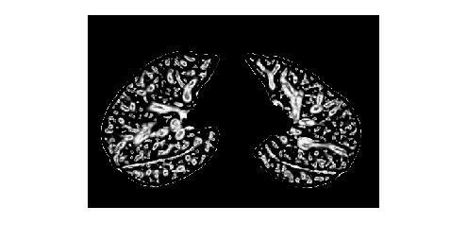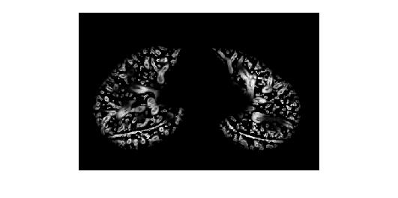 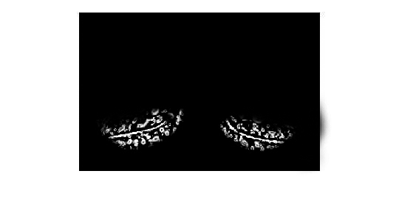

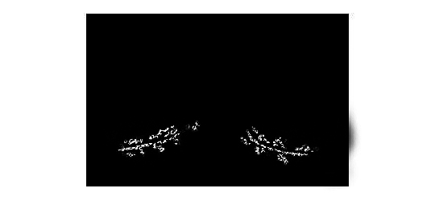 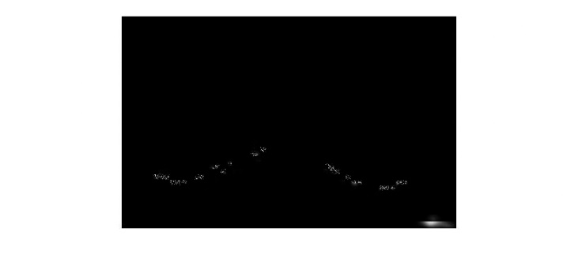 

Interactive user control interface

As we discussed above, a series of parameter values need to be chosen correctly to ensure a successful lobar segmentation. However, one fixed value of a parameter is usually not suitable for all the subjects due to a wide variation of lung tissue and fissure appearances across the population. In addition, current studies show that no automatic segmentation method can ensure a perfect lobe segmentation result for all the subjects, especially for some diseased abnormal cases. Therefore, a fast and convenient interactive method to control the segmentation procedure and correct segmentation result manually is acceptable and reasonable. Based on an open source Pulmonary Toolkit (PTK, <https://github.com/tomdoel/pulmonarytoolkit>), we developed an improved user-friendly interactive interface to control the segmentation procedure. By making use of some built-in objects and visualization system, we add our lobe segmentation algorithm into the toolkit, parameter control buttons and manual correction tools in the packages.

In addition, although a highly automatic lobe segmentation algorithm is more convenient and time-saving for practical application, user interactive correction of the segmentation result is still acceptable. That is because it seems impossible all the subjects can be segmented accurately enough using an automatic algorithm without any manual operations and corrections would be important for some abnormal errors and anatomy. Therefore, a quicker and less manually interactive correction method is required and it is also important to make the automatic stage as reliable as possible.

1. Experiment

3.1 Data

We tested our automatic lobar segmentation result on two different kinds of datasets : 1) CT images of young normal volunteers taken at different lung volumes and with different thickness. These normal subjects are selected from Human Lung Atlas (HLA) dataset which was approved by the University of Iowa Institutional Review Board and Radiation Safety Committees. The selected subjects are consists of 6 functional residual capacity (FRC) cases and 6 total lung capacity (TLC) cases. The thicknesses of the scans vary from 0.5mm to 0.8mm. 2) Clinical CT images of old patients diagnosed with idiopathic pulmonary fibrosis (IPF) disease taken with different thickness. These diseased subjects are all acquired from Auckland District Health Board (ADHB) under the supervision of Dr. Wilsher, following ethics committee approval for this study. The reconstructed slice thicknesses of the IPF scans ranged from … to ….

* 1. Result

To assess the accuracy of the automatic lobar segmentation method in the normal and disease subjects, we compared the automatic segmentation results to the manual ones with digitizing all the three fissures. The fissure points were selected on 2D cross sections and sagittal slices manually. The quantitative evaluation of the segmentation accuracy was assessed from computing the mean difference and the percentile measurement. The mean difference is defined as the mean distance between each manual fissure point and its closet voxel in automatic lobar segmentations:

$$d_{i}^{min}=\begin{matrix}min \\ j\end{matrix}\left\{\sqrt{{(x_{j}^{a}-x_{i}^{m})}^{2}+{(y_{j}^{a}-y_{i}^{m})}^{2}} \right\}$$

$$d_{mean}=\frac{(\sum_{i=1}^{n}{d_{i}^{min}})}{n}$$

Where

The percentile measurement is defined as the percentage of the distance between manual and automatic point under 3mm criteria, following the equation:

$$\sqrt{{(x_{i}^{a}-x_{i}^{m})}^{2}+{(y_{i}^{a}-y_{i}^{m})}^{2}}≤3mm$$

since 3mm approximates the thickness of clinical CT images that surgeons and radiologists read in clinical settings.

The quantitative analysis of the segmentation result is shown in Fig.

1. Conclusions and Discussions

In this study, we developed a pulmonary lobar segmentation method combined with some manual interaction. The result shows that our segmentation method can perform well on CT images of normal subjects and get a relative accurate result for most of the IPF abnormal subjects. In the future work, a statistical lung shape model dataset could be developed which contains different kinds of average statistical shape model with different ages, sexes, lung volume or diseases. The individual selection of statistical shape model is more likely to provide an accurate ROI for the future fissure detection. The method need to be tested on different types of abnormal subjects and be improved combined with the disease characteristic of these images. A user-friendly interaction and faster programming is also a key point in the future study.

Reference